PAPER TITLE (USE CAPITAL LETTERS, CENTER, ARIAL, SIZE 9, BOLD, DO NOT USE ABBREVIATIONS HERE)
Author Name SURNAME¹, Author Name SURNAME² (Arial, 9pt)
¹ Name of the Company/University and e-mail address (Arial, Size 9, Italic)
² Name of the Company/University and e-mail address (Arial, Size 9, Italic)
ABSTRACT (ARIAL, SIZE 9, BOLD)
The body of your abstract begins here. The abstract should be a summary of your paper, including objectives, brief methodology and results of the study. Please avoid using scientific or engineering symbols, acronyms and bullets. Use italics for non-English words and for all kinds of titles (books, plays, movies, and newspapers). Do not use italics for names of persons or organizations or for geographical terms. Titles in italics are not put between quotation marks. Please avoid using any footnotes or endnotes. (These features of Microsoft Word or similar programs create difficulties during the design process.) The abstract should be typed single-spaced line Arial in Size 9. Be sure to adhere to the word limitation (200-250 words).
Key Words (Arial, Size 9, Bold): Max. 5 keywords separated with semicolons (Arial, Size 9).

INTRODUCTION (ARIAL, SIZE 9, BOLD)
Papers will be reproduced exactly as submitted and will not be edited in any way.
Abbreviations should be kept to a minimum. Use of standard abbreviations is acceptable. Place special or unusual abbreviations in parentheses after the full term for the first time it appears. Linguistic accuracy is the responsibility of the authors.
Please avoid using scientific or engineering symbols, acronyms and bullets. Use italics for non-English words and for all kinds of titles (books, plays, movies, and newspapers). Do not use italics for names of persons or organizations or for geographical terms. Titles in italics are not put between quotation marks.
Please avoid using any footnotes or endnotes. (These features of Microsoft Word or similar programs create difficulties during the design process.)
Please note that the full paper should not exceed 15 pages including text, figures and tables.
Language: Papers should be written in English Language.
Font: Arial, Size 9.
Page Setup: It is strongly recommended to observe this given paper format. We kindly advice you to input your paper text in this document which is already properly formatted.
Tables: Center and number each table. Put each table headings above the table - Align Center.
Table 1. Example

Figures: Center and number each figure/image. Put each figure/image caption below the figure/image - Align Center. All the figures should have 300 dpi resolution.
All the figures and information graphics should be placed in the text. (Uploading the figures or graphics separately from the text through LivenARCH 2021 web-site may cause some technical problems.)
All objects used in one figure should be grouped.
Drawings (figure, charts) should be prepared with minimum line weight ½ pt.
Formulas should be typewritten (use, e.g., Microsoft Equation Editor).

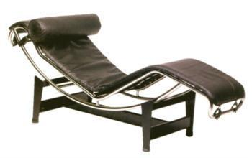 | 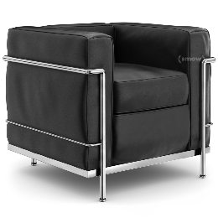
Figure 1. Example
Subheadings (Arial, Size 9, Bold)
Give all the subheadings, including the methods and the others related to your paper content (Arial, Size 9).
CONCLUSION (ARIAL, SIZE 9, BOLD)
Summarize the results of the paper and write the conclusion (Arial, Size 9). Papers without CONCLUSION will NOT be published.
ACKNOWLEDGEMENTS (ARIAL, SIZE 9, BOLD)
This section is optional (Arial, Size 9).
REFERENCES (ARIAL, SIZE 9, BOLD)
APA 6th Reference Style
For details visit: https://www.mendeley.com/guides/apa-citation-guide
Papers without REFERENCES will NOT be published.

Important Notes for the Authors:
Papers’ file name must be Author Surname.doc
For papers with more than one authors, files should be named as: First Author Surname_Second Author Surname.doc
Please upload your full paper using online submission: www.livenarch.org

